NAME: NAVODITAA A.R
ROLL NO: 241901071

6. DEMONSTRATE LINUXPRIVILEGE ESCALATION
DATE: 04/03/2026
Aim:
To learn the fundamentals of Linux privilege escalation ,from enumeration to exploitation, get handson with over 8 different privilege escalation techniques.
Procedure:
- Log into TryHackMe and open the Linux Privilege Escalation room.
- Perform enumeration to gather system and user information.
- Identify potential misconfigurations and vulnerabilities.
- Study common techniques such as SUID, cron jobs, and PATH manipulation.
- Analyze how to exploit these weaknesses to gain elevated privileges.
- Complete the tasks and answer the questions in the room.
- Review the summary and confirm completion.
Tasks: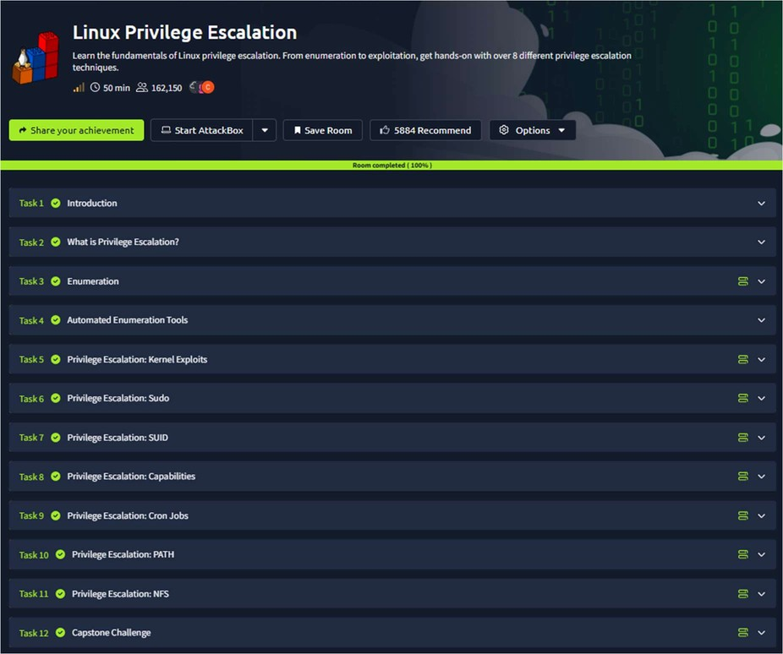
TASK 1 - Introduction
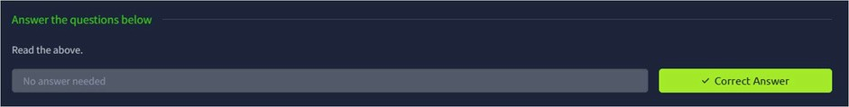
TASK 2 – What is Privilege Escalation?
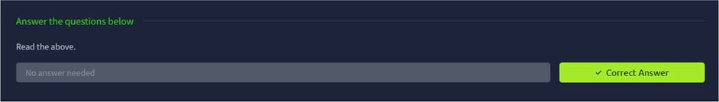
TASK 3 – Enumeration
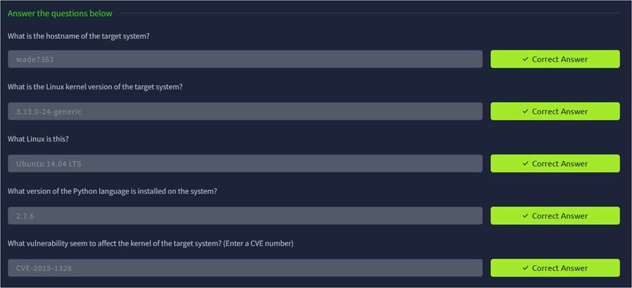
TASK 4 – Automated Enumeration Tools
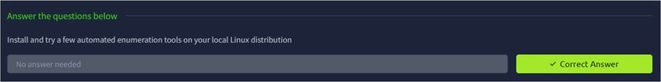
TASK 5 – Privilege Escalation – Kernel Exploits
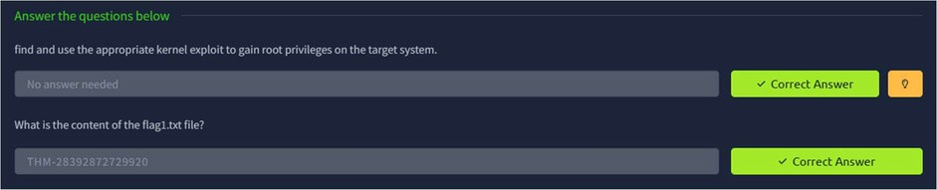
TASK 6 – Privilege Escalation : Sudo
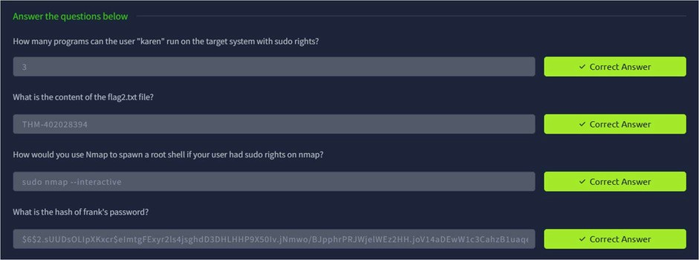
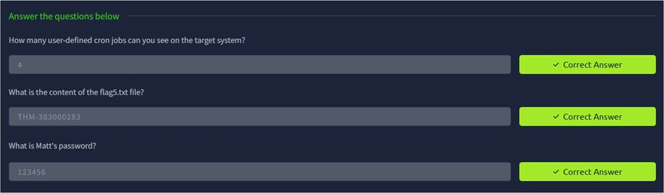
TASK 7 – Privilege Escalation : SUID
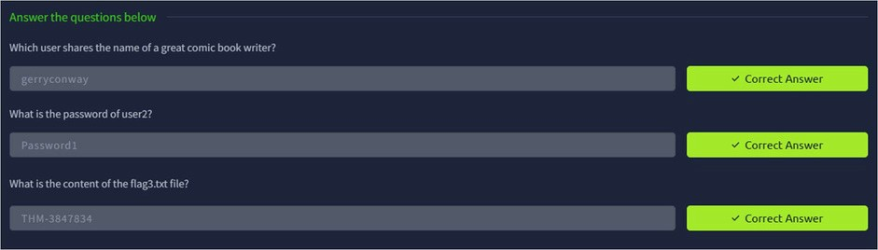
TASK 8 – Privilege Escalation :. Capabilities
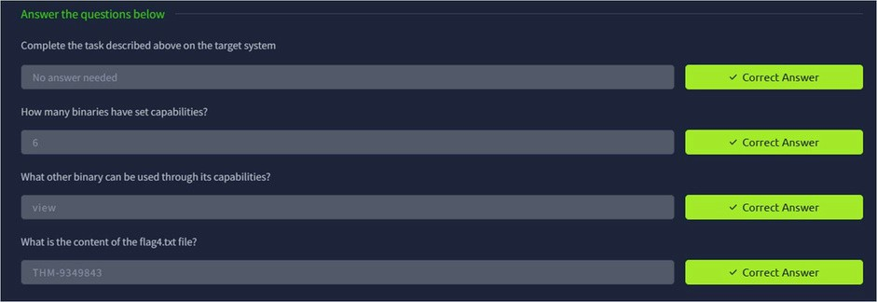
TASK 9 – Privilege Escalation : Cron Jobs

TASK 10 – Privilege Escalation : PATH
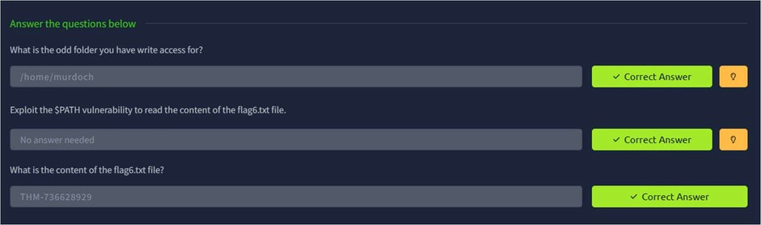
TASK 11 – Privilege Escalation : NFS
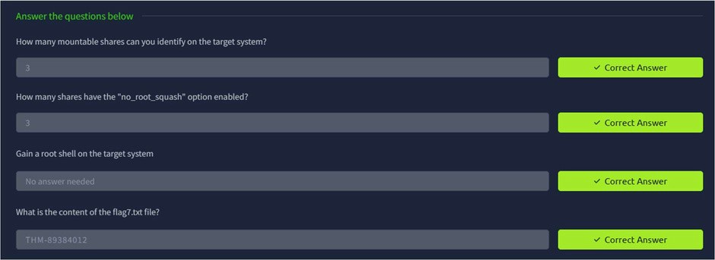
TASK 12 – Capstone Challenge
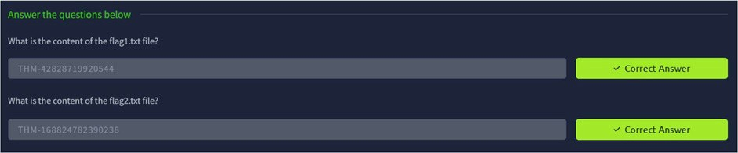
Result:
Thus the TryHackMe room Linux Privilege Escalation was completed successfully.

